Arafat’s Edits
Methods: We collected data from 122 participants (70 controls, 52 with MS) wearing an ActiGraph accelerometer on the back during a 6-minute walk. Signals were resampled to 30 Hz. Gravity was estimated with a zero-phase, 4th-order Butterworth low-pass filter (0.25 Hz) and subtracted. Axes were aligned to mediolateral (ML), anteroposterior (AP), and vertical (VT; superior–inferior) using the gravity vector to define VT and a horizontal-plane rotation to obtain orthogonal ML and AP. Activity intensity was computed as Euclidean Norm Minus One (ENMO) from the raw signal before removing gravity. Mediolateral sway was quantified as the root-mean-square (RMS) of ML acceleration. Two normalized sway features were derived: ML/ENMO (ML RMS divided by mean ENMO) and ML/VT (ML RMS divided by VT RMS). Between-group differences were assessed using Mann-Whitney U or Welch’s t-test as appropriate and correlation with 6-minute walk distance (6MWD) was calculated using Spearman’s rank correlation. p-values were adjusted using the Benjamini–Hochberg procedure to control the false discovery rate (FDR).
Results: Both normalized sway features were significantly higher in the MS group than in controls. For ML/ENMO, MS had median 1.14 (95% CI: 0.67–2.60) versus 0.89 (95% CI: 0.88–0.98) in controls (FDR-adjusted p = 1.52 x 10⁻⁴). For ML/VT, MS had median 0.57 (95% CI: 0.52–0.61) versus 0.45 (95% CI: 0.44–0.50) in controls (FDR-adjusted p = 8.77 x 10⁻⁴). Across participants, greater sway was associated with shorter walking capacity, with moderate negative correlations between sway and 6MWD (ML/ENMO: Spearman’s $ρ = -0.42$, p = 1.5 x 10⁻⁵); (ML/VT: $ρ = -0.25$, p = 1.2 x 10⁻²). These findings indicate that, to achieve the same activity intensity, MS patients showed greater ML sway and reduced dynamic stability during gait.

Ariful’s Edit

Data Processing
To minimize noise and retain relevant motion components, the raw triaxial accelerometer signals were preprocessed using a fourth-order Butterworth bandpass filter with cutoff frequencies of 0.1 Hz and 15 Hz. The lower cutoff attenuates baseline drift and gravitational effects, while the upper cutoff removes high-frequency noise unrelated to human motion. Following filtering, each axis ($X,Y,Z$) was normalized to the range $\left[-1,1\right]$ to reduce inter-sensor variability and ensure consistent amplitude scaling across participants. The resultant magnitude signal was computed as-
$$a_{mag}(t)=\sqrt{a_{X}^{2}(t)+a_{Y}^{2}(t)+a_{Z}^{2}(t)},$$
representing the overall acceleration intensity at each time instant. This preprocessing step enhanced signal quality and preserved the fundamental temporal and spectral characteristics necessary for subsequent feature extraction and time–frequency analysis.
CWT
The continuous wavelet transform (CWT) can provide a precise time-frequency representation of a signal [1]. It has been shown that the Morlet wavelet effectively captures gait-related spatio-temporal characteristics from acceleration signals obtained from different body locations [2]. As postural sway is a non-stationary or time varying process the time-frequency analysis can reveal the spectral content of postural sway [3].
Feature Extraction:
Estimated Cadence (estimated_cadence): The average step rate (steps/min), computed from the dominant frequency of the time-averaged CWT power spectrum.
Dominant Frequency (dominant_freq): The frequency corresponds to the highest average power across time, representing the most prominent gait rhythm.
High-Frequency Energy (high_freq_energy): The total signal energy within the higher frequency band (3.5–12 Hz), reflecting rapid oscillations or high-frequency motion components.
Wavelet Entropy (entropy): A measure of the spectral complexity of the CWT power distribution, indicating the irregularity or variability in gait dynamics.
Maximum Power Frequency (max_freq): The instantaneous frequency corresponding to the global maximum power in the CWT time–frequency matrix.
Frequency Variability (freq_std): The standard deviation of dominant frequencies over time, capturing fluctuations in gait rhythm stability.
Coefficient of Frequency Variation (freq_cv): The normalized measure of gait frequency variability, computed as the ratio of frequency standard deviation to mean frequency.
Harmonic Ratio (HR): The ratio of even-to-odd harmonic energies derived from the FFT of the acceleration magnitude, representing gait symmetry and smoothness.
Fundamental Frequency (f0): The base gait oscillation frequency identified from the FFT spectrum within the physiological walking range (0.5–3.5 Hz).

Results and Discussion
Mixed-Effects Modeling of Gait Time-Frequency Features
Linear mixed-effects modeling was performed to evaluate group-level and temporal differences in sway and gait features between individuals with multiple sclerosis (MS) and healthy controls during the 6-Minute Walk Test (6MWT). The Group effect reflects the overall difference in feature values between MS and control participants, the Segment effect represents changes in each feature across the six one-minute segments of the test, and the Group × Segment interaction effect indicates whether the temporal pattern of change differs between the two groups.
A series of linear mixed-effects models (LMMs) were fitted independently for each extracted feature using the lmerTest package in R. For each feature, the following model was specified:
$${\text{Feature}}_{ij}=β_{0}+β_{1}{\text{Group}}_{i}+β_{2}{\text{Segment}}_{j}+β_{3}({\text{Group}}_{i}×{\text{Segment}}_{j})+u_{i}+ϵ_{ij}$$
Where Group represents MS or control participants, Segment denotes the minute of the 6MWT, and uᵢ is a random intercept for subject ID to account for repeated measures within participants.
To account for intra-subject variability across time, a random intercept term (1 | Subject_ID) was included. This allows each participant to have their own baseline level of each feature, thereby controlling within-subject correlations and improving the precision of fixed-effect estimates. The mixed-effects framework was chosen for its robustness in modeling hierarchically structured data with both between- and within-subject variability.
Type III ANOVA with Satterthwaite’s approximation was applied to obtain p-values for fixed effects (Group, Segment, and Group × Segment) [4], [5]. This approach was selected because the dataset was slightly unbalanced and included interaction terms, making Type III sums of squares the most appropriate method for producing unbiased inference. Unlike Type I or II ANOVA, which assume balanced or orthogonal designs, Type III ANOVA tests each effect after accounting for all other terms in the model—including interactions—ensuring that each p-value reflects the unique contribution of that effect to explaining variance in the feature.
To synthesize results across all features, p-values for each fixed effect were extracted and compiled into a summary table. False Discovery Rate (FDR) correction was then applied to control for multiple comparisons across features, producing adjusted q-values for each effect. Features were subsequently ranked based on their FDR-adjusted significance levels (q-values), allowing identification of the most discriminative features between groups, the most time-varying features across segments, and those exhibiting significant group-by-time interaction effects.
Results:
After false discovery rate (FDR) correction, significant Group effects were observed for mean_energy (q < 0.001), high_freq_energy (q = 0.023), freq_variability (q < 0.001), freq_cof_variation (q < 0.001), and wavelet_entropy (q = 0.043), indicating that MS participants exhibited higher overall mean energy and greater frequency-domain irregularity than controls. Significant Segment effects were identified for mean_energy, high_freq_energy, freq_cof_variation, harmonic_ratio, fundamental_freq, and wavelet_entropy (all q < 0.05), suggesting temporal changes in postural and gait features across the 6MWT, possibly due to fatigue or adaptation over time.
Importantly, significant Group × Segment interaction effects were found for mean_energy (q = 0.025) and high_freq_energy (q = 0.025), demonstrating that the evolution of these features over time differed between MS and control groups. This indicates that MS participants exhibited distinct patterns of energy distribution and postural adjustment throughout the walking task. Collectively, these results highlight that energy-based and frequency-domain features derived from the continuous wavelet transform effectively capture both static group-level differences and dynamic adaptations in postural control associated with multiple sclerosis.
feature | p_group | p_segment | p_group_segment | p_group_FDR | p_segment_FDR | p_group_  segment_FDR
mean_energy | < 0.001 | <0.001 | 0.00494 | <0.001 | <0.001 | 0.0247
high_freq_energy | 0.00923 | <0.001 | 0.0033 | 0.0231 | <0.001 | 0.0247
freq_variability | < 0.001 | 0.2684 | 0.0406 | <0.001 | 0.2982 | 0.1353
freq_cof_variation | < 0.001 | <0.001 | 0.35803 | <0.001 | <0.001 | 0.7664
harmonic_ratio | 0.10575 | 0.0137 | 0.61316 | 0.1763 | 0.0257 | 0.7664
fundamental_freq | 0.49007 | 0.0154 | 0.57019 | 0.5445 | 0.0257 | 0.7664
estimated_cadence | 0.36975 | 0.122 | 0.46034 | 0.4622 | 0.1525 | 0.7664
dominant_freq | 0.36975 | 0.122 | 0.46034 | 0.4622 | 0.1525 | 0.7664
max_power_freq | 0.58832 | 0.542 | 0.93595 | 0.5883 | 0.542 | 0.9388
wavelet_entropy | 0.02154 | <0.001 | 0.93883 | 0.0431 | <0.001 | 0.9388

Statistical Analysis (Minute by Minute)
Result:
Mean Energy
To further investigate the significant Group × Segment interaction observed for mean_energy, estimated marginal means (EMMs) were computed for each segment of the 6-Minute Walk Test (6MWT) using the Kenward–Roger approximation for degrees of freedom.
The mixed-effects model revealed significant main effects of Group (p = 0.005) and Segment (p < 0.01), as well as significant Group × Segment interactions at several time points (p < 0.05). Across all segments, participants with multiple sclerosis (MS) consistently exhibited higher mean energy values than controls. The group difference increased over time—from an estimated difference of 0.68 at minute 1 (p = 0.005) to 1.19 at minute 5 (p < 0.001)—indicating a widening gap in movement energy as the test progressed.
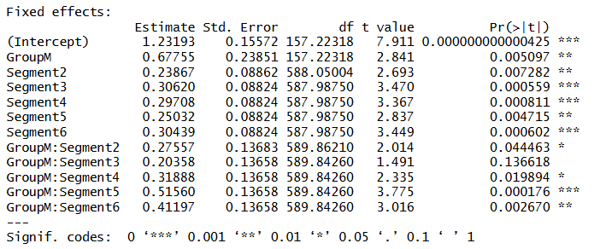
The estimated marginal means further showed that mean energy in the MS group increased steadily from 1.91 (95% CI: 1.55–2.27) in the first minute to 2.68 (95% CI: 2.32–3.03) by the fifth minute (Figure 1a), whereas the control group remained relatively stable (1.23–1.54 across all segments). This divergence suggests that MS participants required progressively greater movement effort or exhibited increased postural instability as fatigue accumulated during the 6MWT.
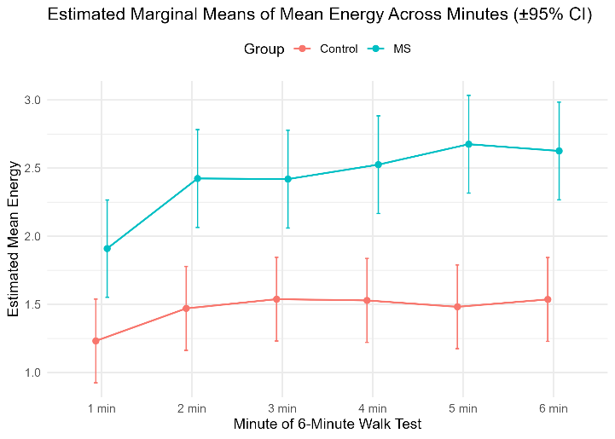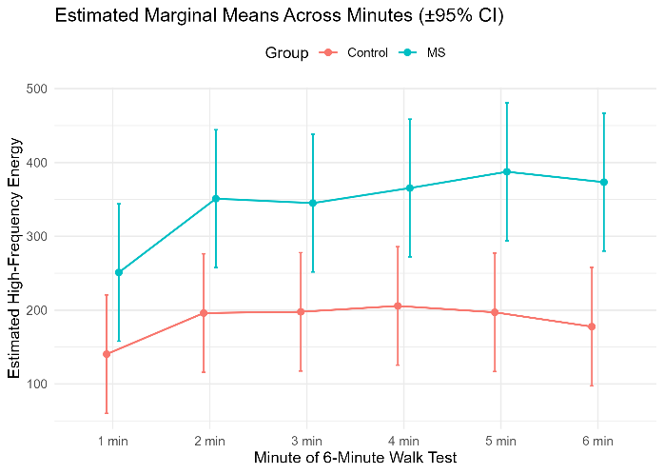
Figure 1: Estimated Marginal Means across control and MS patients. a) Mean energy, b) high frequency energy.
High-Frequency Energy
The mixed-effects model for high_freq_energy revealed significant Segment effects (p < 0.01) and Group × Segment interactions at several time points (p < 0.05), while the overall Group effect approached significance (p = 0.077). Estimated marginal means indicated that participants with multiple sclerosis (MS) exhibited higher high-frequency energy across all segments compared to controls, with the difference becoming more pronounced as the 6-Minute Walk Test (6MWT) progressed.
Specifically, the estimated difference between groups increased from 111 units at minute 1 (p = 0.077) to 196 units at minute 6 (p = 0.002). Within-group trends showed that high-frequency energy rose from 251 (95% CI: 157–344) to 387 (95% CI: 294–481) for the MS group, whereas controls showed relatively stable values ranging from 140 (95% CI: 60–221) to 197 (95% CI: 117–277). These patterns indicate that MS participants exhibited a progressive increase in higher-frequency sway components, reflecting heightened postural adjustments or instability as fatigue accumulated over time.
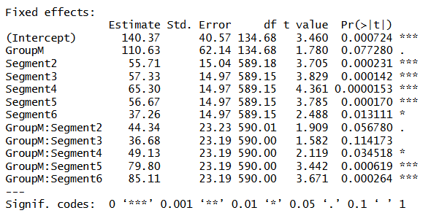

Research Question:
Does postural sway impact performance on 6 minute walk – and if so, does this impact both control and MS performance (or just MS performance)?
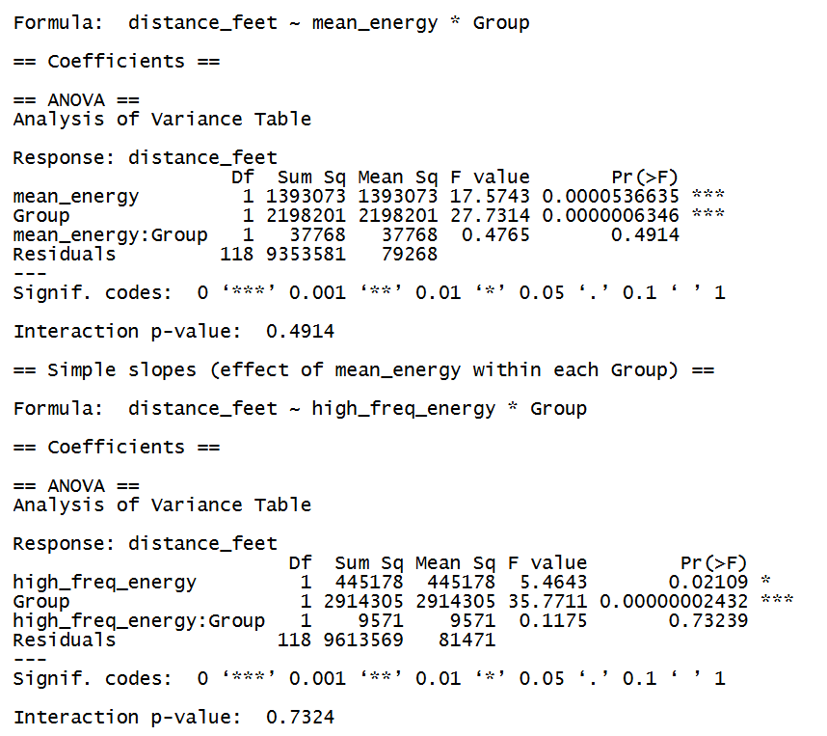
Method
To evaluate whether postural sway influences walking performance, we examined the association between sway-derived frequency domain features and the total distance covered during the 6-minute walk test (6MWT).
For each participant, we extracted 10-time frequency features and previous shfound only mean energy and high-frequency energy (5–12 Hz) are significant. We extracted these features from the continuous wavelet transform (CWT) of the accelerometer signals recorded during quiet standing.
The 6MW distance (in feet) was used as the dependent variable, and Group (Control vs. MS) was treated as a categorical factor.
We fit separate linear regression models for each sway feature using the following structure:
$$\text{distance_feet}=β_{0}+β_{1}(\text{sway feature})+β_{2}(\text{Group})+β_{3}(\text{sway feature}×\text{Group})+ε$$
This allowed us to test (a) whether sway features predicted 6MW distance across participants and (b) whether that relationship differed between groups.
Model significance was assessed using ANOVA, and group-specific slopes were estimated using the emtrends function in R (emmeans package).

Results:
Two separate two-way interaction linear regression models (equivalent to 2×2 ANOVA designs) were conducted to examine the effect of the group (Multiple Sclerosis [MS] vs. Control) and two distinct measures of postural sway (mean_energy and high_freq_energy) on 6-minute walk distance (distance_feet). The Control group was used as the reference category for the Group variable.

1. Postural Sway (mean_energy) and Performance
The first model tested the effect of the interaction between mean_energy and Group on distance_feet.
Group Main Effect
A strong, significant main effect of Group was found (GroupM estimate: −355.99 feet, p=0.0013). This indicates that, on average, the MS group walked significantly shorter distances (≈356 feet less) than the Control group, after controlling for mean_energy.

Energy Main Effect
The ANOVA table indicated a highly significant overall main effect for mean_energy on distance_feet (F(1,118)=17.57,p<0.001). This confirms that higher levels of mean energy (sway) were significantly associated with changes in walking performance. However, the simple slope for mean_energy within the Control group was not individually significant (β=−119.45,p=0.2403).
Interaction Effect
The interaction term (mean_energy:GroupM) was not statistically significant (β=72.42,p=0.4914). This is interesting as it demonstrates that the relationship between mean_energy (sway) and distance_feet (performance) does not significantly differ between the MS and Control groups. The impact of mean_energy on walking performance is consistent across both cohorts.
2. Postural Sway (high_freq_energy) and Performance
The second model tested the interaction between high_freq_energy and Group on distance_feet.

Group Main Effect
A highly significant main effect of Group was again observed (GroupM estimate: −291.62 feet, p=0.0045). Similar to the first model, the MS group walked significantly shorter distances (≈292 feet less) than the Control group, controlling for high_freq_energy.
Energy Main Effect
The ANOVA table indicated a significant overall main effect for high_freq_energy on distance_feet (F(1,118)=5.46,p=0.021). The simple slope for high_freq_energy within the Control group was not individually significant (β=0.024,p=0.8330).
Interaction Effect
The interaction term (high_freq_energy:GroupM) was not statistically significant (β=−0.039,p=0.7324). This reinforces the finding from Model 1: the relationship between high_freq_energy (sway) and distance_feet (performance) is consistent across both the MS and Control groups.
Summary of Findings
The finding supports the conclusion that: (1) The MS group exhibits significantly lower walking performance than the Control group; and (2) Postural sway is significantly related to walking performance. However, based on the non-significant interaction terms, the impact of postural sway on walking performance is not unique to the MS group, but is a relationship observed similarly in both the MS and Control cohorts.
References:
[1] P. S. Addison, J. Walker, and R. C. Guido, “Time–frequency analysis of biosignals,” IEEE Eng. Med. Biol. Mag., vol. 28, no. 5, pp. 14–29, Sep./Oct. 2009.
[2] S. Khandelwal and N. Wickström, “Novel methodology for estimating initial contact events from accelerometers positioned at different body locations,” Gait Posture, vol. 59, pp. 278–285, 2018.
[3] Schumann, T., Redfern, M. S., Furman, J. M., El-Jaroudi, A., & Chaparro, L. F. (1995). Time-frequency analysis of postural sway. Journal of biomechanics, 28(5), 603-607.
[4] Kuznetsova, A., Brockhoff, P. B., & Christensen, R. H. (2017). lmerTest package: tests in linear mixed effects models. Journal of statistical software, 82, 1-26.
[5] Luke, S. G. (2017). Evaluating significance in linear mixed-effects models in R. Behavior research methods, 49(4), 1494-1502.

